https://docs.microsoft.com/en-us/windows/desktop/winauto/system-provided-user-interface-elements:

System-Provided User Interface Elements (docs.microsoft.com)
05/31/2018, 2 minutes to read
Microsoft Active Accessibility provides support for most predefined and common controls. The following illustration shows a typical window and some of the system-provided user interface elements that Microsoft Active Accessibility exposes, such as title bars, menus, combo boxes, toolbar controls, tree view controls, status bars, size grips, list-view controls, and scroll bars.
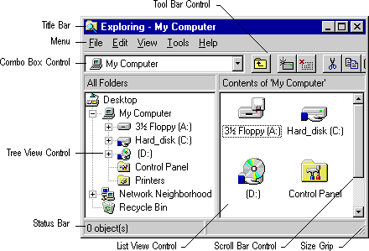
Microsoft Active Accessibility exposes system-provided user interface elements to server applications without requiring the server developer to implement the IAccessible interface. Any application that contains these elements automatically inherits their accessibility.
For a list of the controls and other system-provided user interface elements that Microsoft Active Accessibility supports, see Appendix A: Supported User Interface Elements Reference.

